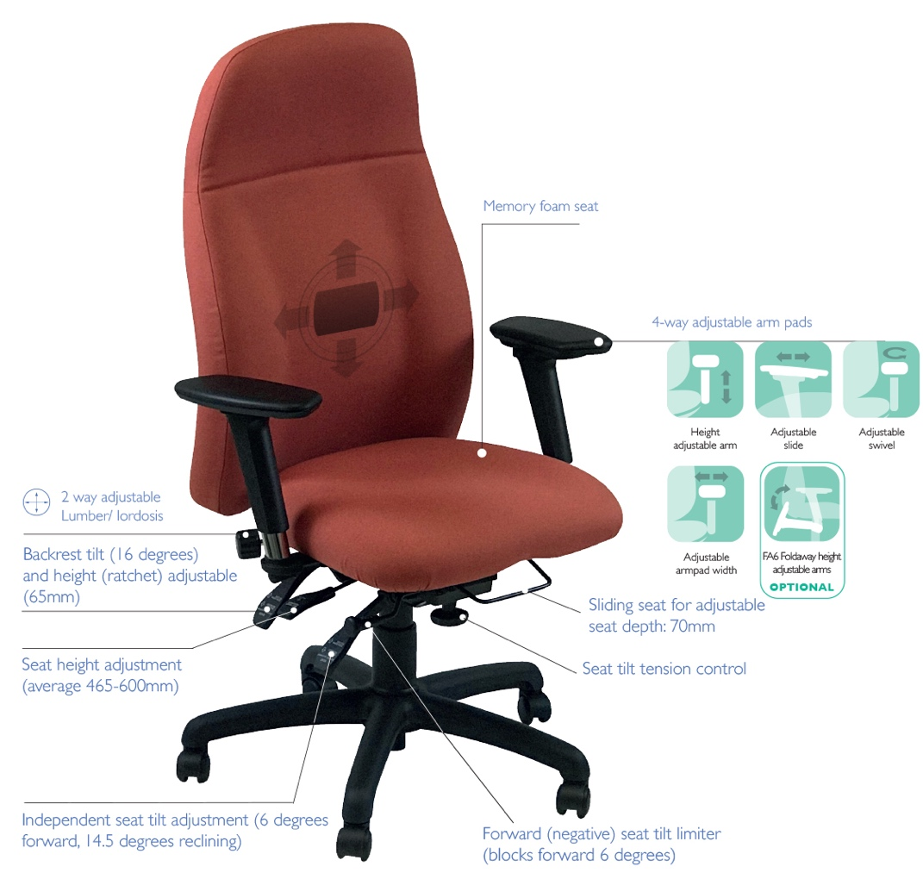
The rounded back style Spynamics models provide an effective ‘Access to Work’ seating solution; where a comfortable, supportive and adjustable ‘bad back chair’ is required
SD9
SD10
SD11
SD9 SD10 SD11
Chronic back pain seating
For more information and prices, please contact Phil Pask on 07803 120155
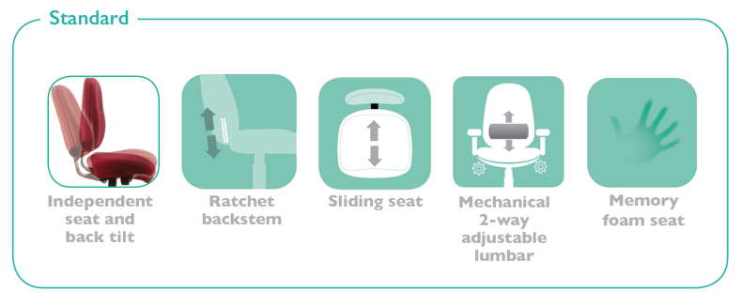

Ergonomic features include:

- Heavy duty 6-way adjustable mechanism provides correct posture and personalised support
- 5-year warranty/8-hour daily use by up to 23.5 stone users
(150kg) for single user application
- Overwork/overweight warranty available for 3 shift pattern
use and users over 23.5 stone
- Seat height min/max adjustment range meets the FIRA
Ergonomic Excellence Award criteria
- Comfort and support enhanced by a memory foam layered seat
- Choice of 3 contoured backs, with 2-way built-in variable lumbar support
- 4-way adjustable arms fitted as standard, other arm options are also available
- Optional coccyx cut out option available as well as a selection of other seat sizes
- Memory foam backs and an adjustable memory foam headrest are among the optional extras

